Program 3 CECS 575/675 Fall 2016 Due Nov 1

1. Write an OO program to implement the FSA depicted below. Use the State design pattern for this program.

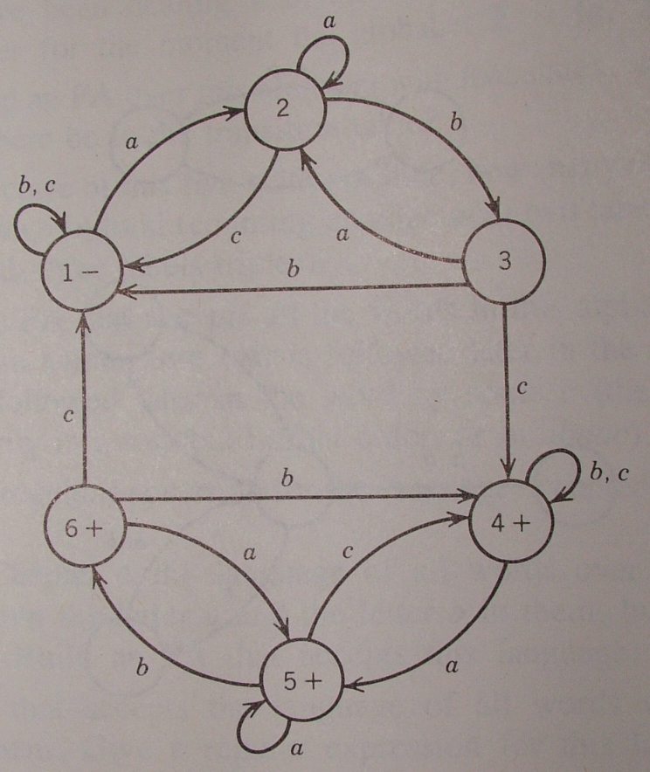

Text input and output are acceptable.

2. What words are accepted by this FSA?

Submit code to BB. Be sure to answer part 2.

